**LAB-04**

**Q1.**

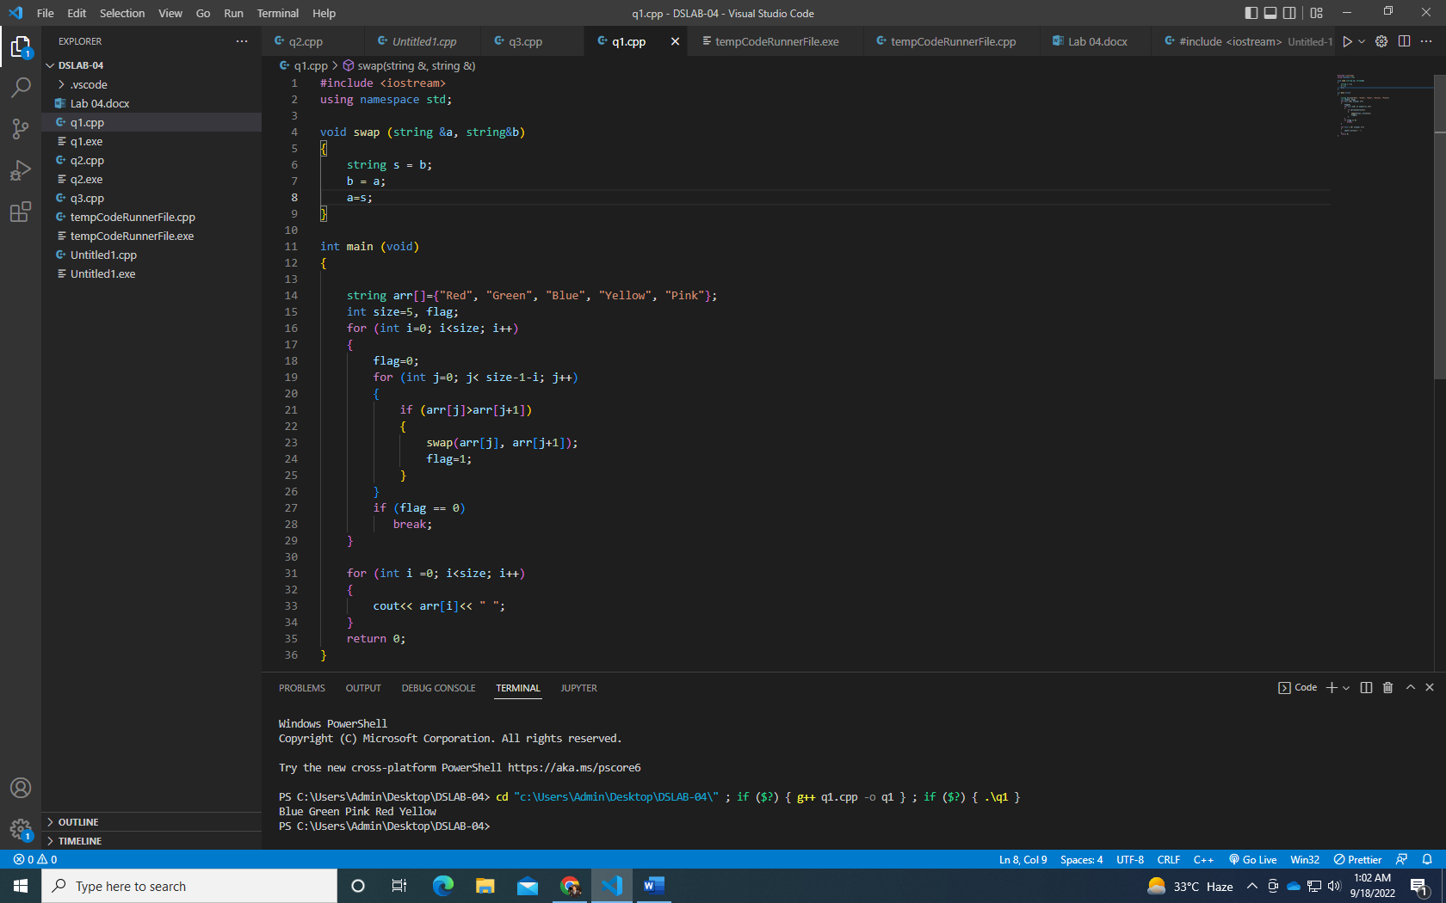

**Q2.**

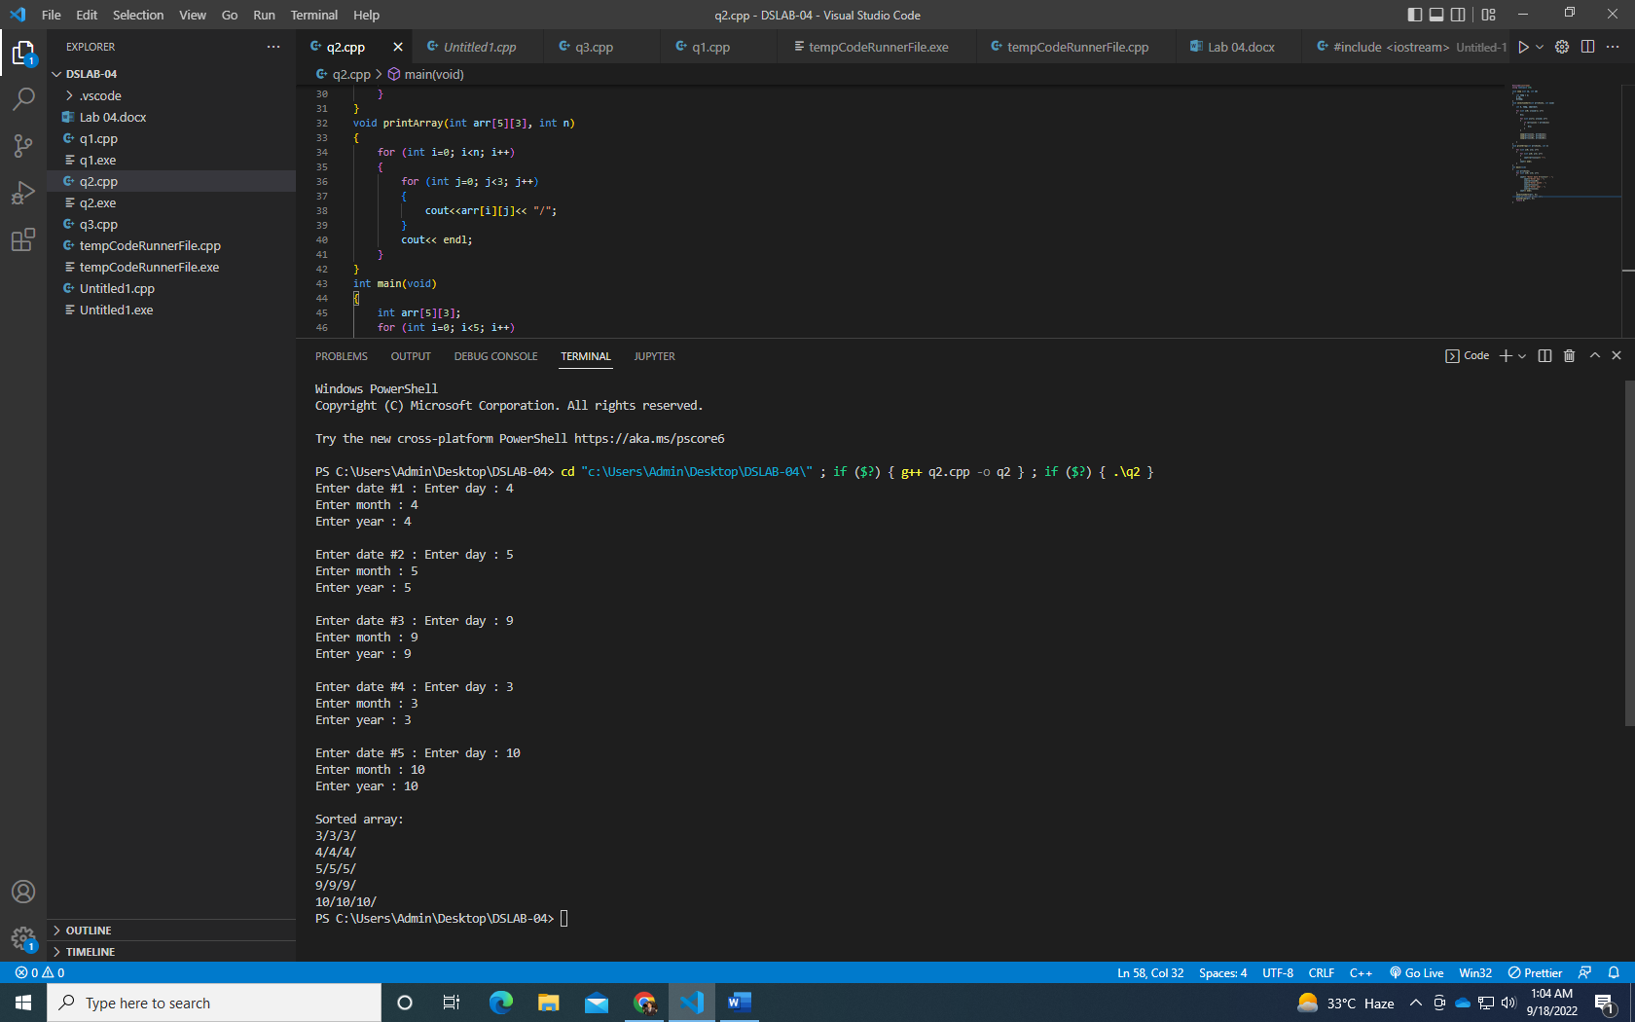

**Q3.**

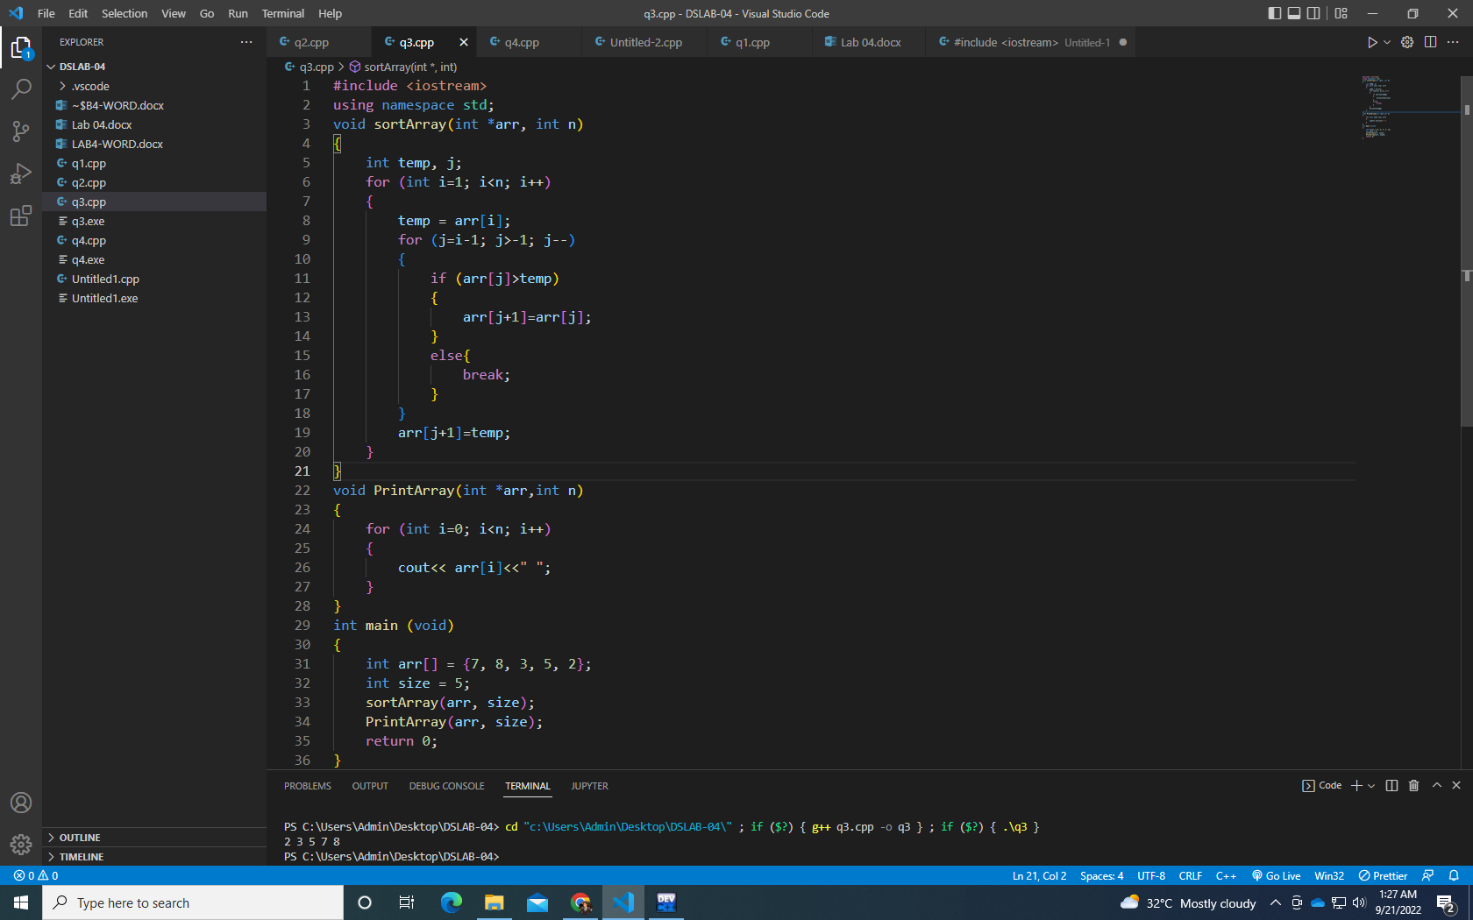

**Q4.**

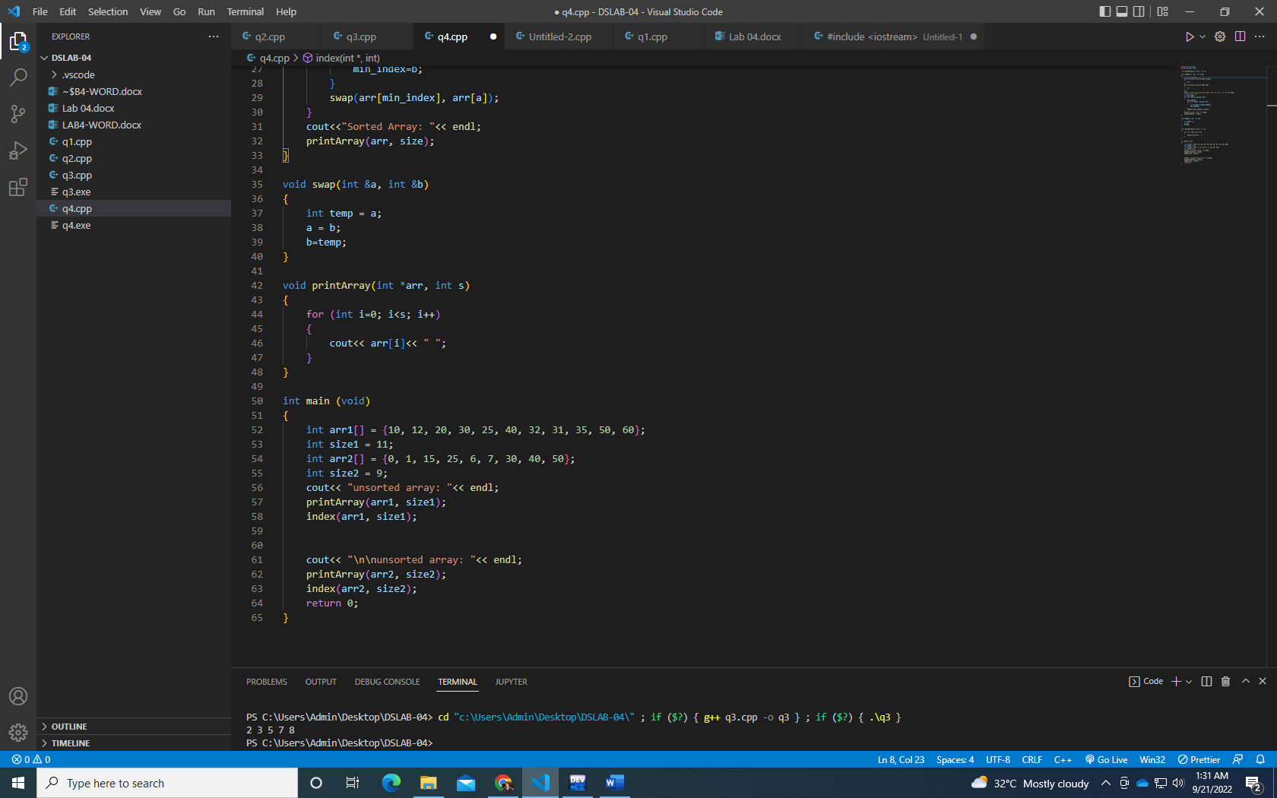

**Q5.**

**Use selection sort since it has least number of swaps as compared to other sorting algorithms also the space complexity is 1 for this algo. The number of comparisons also matter less therefore this is the best technique for this case.**

